COMHAIRLE CHONTAE AN LONGFOIRT

LONGFORD COUNTY COUNCIL

Corporate Affairs,
Please note Venue and Aras an Chontae,
Time of Meeting. LONGFOIRT.

22u Meitheamh 2016.

Chuig: Gach Ball don Chomhairle.

A Chomhairleoir,

Iarrtar ort bheith i láthair ag Cruinniú Ginearálta Bliantúil Chomhairle Chontae Longfoirt a tionólfar i Rustic Inn, Abbeyshrule ar an Chéadaoin
29ú Meitheamh 2016 ag 5.00 p.m chun gnó a dhéanamh d’réir an Chláir thíos.

You are requested to attend the Annual Meeting of Longford County Council to be held in the Rustic Inn, Abbeyshrule on Wednesday, 29th June 2016 at 5.00 p.m. to transact business, as set out on the Agenda hereunder.

Please note - Buffet dinner will follow at 6.00 p.m.

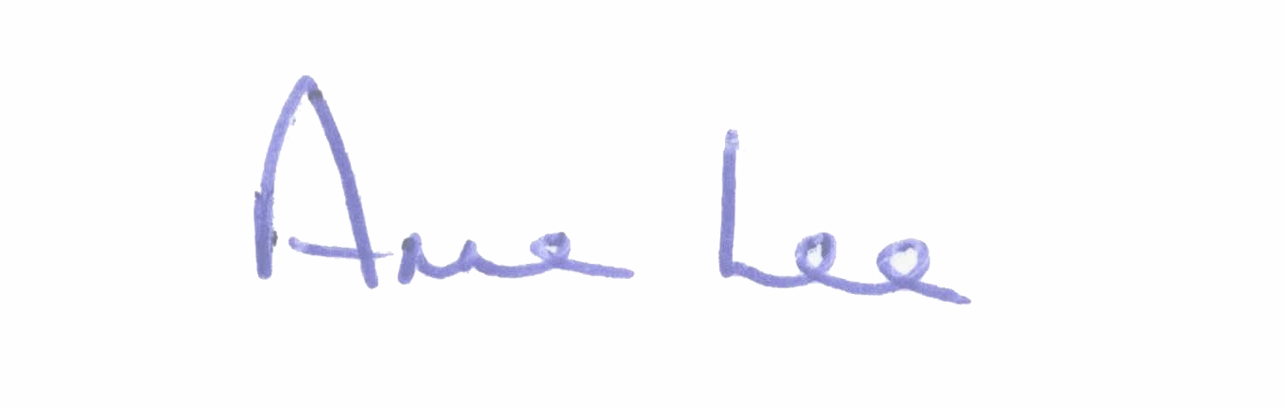
Mise le meas,

_______________________
Anne Lee,
Meetings Administrator.

C L A R

Prayer before Meeting.

- Election of Cathaoirleach.

- Election of Leas Cathaoirleach.

- Fix date and time of meetings.

:::::::::::::::::::::::::::::::::::::::::::::

